1

(a)

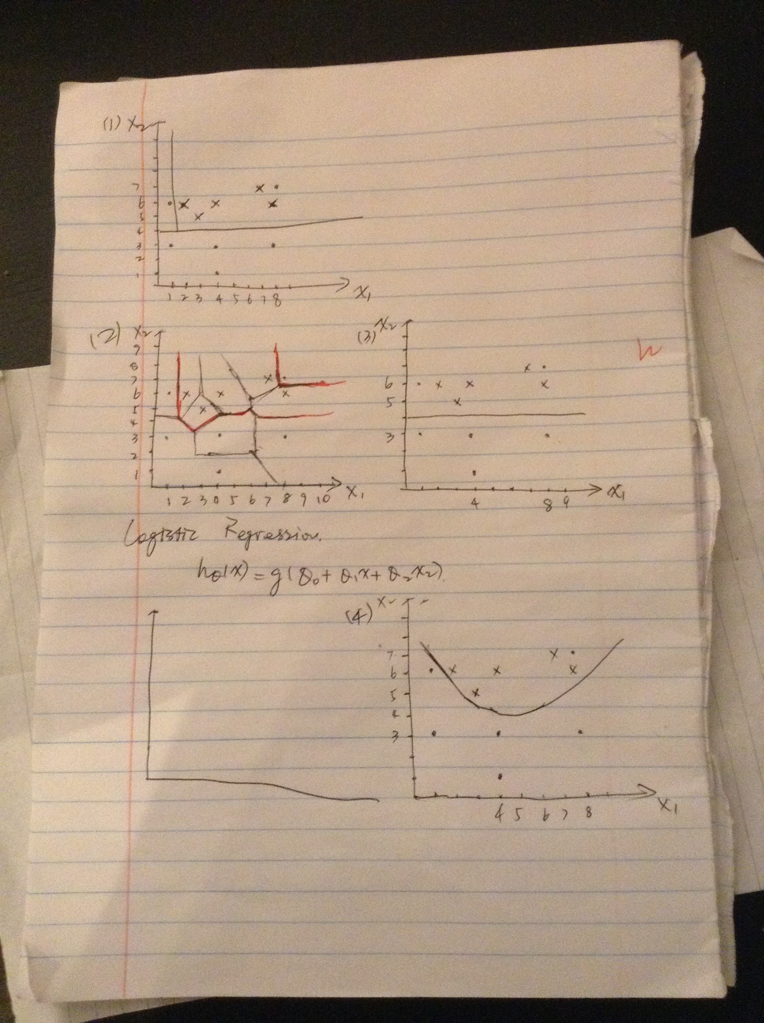

(b)

I think logistic regression with quadratic terms generate the best decision boundary in this case because decision trees and 1-nearest neighbor are both overfitting and plain logistic regression is underfitting in this case.

I think the combination between 1-nearest neighbor and logistic regression with quadratic terms will generate better results because the decision boundary by the nearest neighbor is a more precise line than the other ones and logistic regression with quadratic terms ignores the abnormal point.